

TTG 2023 – DAILY NEWS
OCTOBER 12

POLIMI TRAVEL INNOVATION OBSERVATORY: ITALY EMBRACES DIGITAL TRAVEL
Tourism in Italy is on the rise, leveraged by eCommerce. Accommodation and transport are growing at double digits compared to 2022, while organized tourism is still in distress, recording -2% compared to 2019; travel agencies are making a modest comeback, up by 2%. This is the picture emerging from the Travel Innovation Observatory run by the Milan Polytechnic School of Management, which was presented on the second day of the 60th edition of TTG Travel Experience, underway at Rimini Expo Centre until Friday October 13th. The research team led by Filippo Renga and Eleonora Lorenzini presented the results of the Observatory to the industry at the international trade show organized by Italian Exhibition Group. Transport has grown 41% on 2022, and in particular by 9% on 2019, for a total value of 23.7 billion in the three sectors – incoming, domestic and outgoing.
If in 2019, the incidence of online purchases in the industry was 55% of the total, in 2023, over 7 out of 10 euros spent (71%) have been digital transactions; in particular, digital users are much more likely to book through direct channels than indirect ones. Accommodation has registered an 11% increase compared to 2022, exceeding 2019 levels by 7%, with hotels and non-hotels reaching 35.8 billion, boosted by eCommerce, accounting for 19.4 billion (2.9 billion more than in 2022). And while travel agencies managed to bounce back from the pandemic period, with +2% of transactions compared to 2019, tour operating values (excluding cruises) are still slightly lower than 2019 (-2%).

CONFCOMMERCIO: 60 MILLION ITALIAN EXPATS WANT TO COME BACK AND PUT DOWN ROOTS
Sixty million Italians abroad are ready to put down roots in their country of origin. With a journey that reconnects them to their family and cultural origins, driven by the powerful pull of Italian cuisine. 2024 is the year of roots tourism, when we return to visit and experience the places of our ancestors. A huge community in search of rediscovering its origins and with immense spending power, eager to know and fully experience Italy, which could generate an annual expenditure in the country in the range of 8 billion euros. This emerges from an analysis presented today at TTG, organized by IEG at the Rimini Expo Centre, in a report by Confcommercio (also present, President Carlo Sangalli) and SWG on Italian communities in eight countries: Argentina, Australia, Brazil, Canada, France, Germany, the United Kingdom and the USA. Of this potential pool, 84% speak Italian well, with 9 out of 10 speaking it at home. 82% usually eat Italian cuisine. Only 12% of those interviewed have never been to Italy, and 6 out of 10 have come or returned several times over the years: especially those born in our country and their partners, while the tendency to come to Italy decreases as the years pass, it has been revived - 63% of cases - among those who, despite not being certain of having origins in our country, are intrigued by the idea and are trying to reconstruct a connection. The type of planned accommodation has also undergone a major change: only 27% plan to stay overnight at the homes of relatives and friends, while 35% focus on hotels and a further 16% on other types of tourist accommodation facilities. The budget for a holiday that almost 4 out of 10 plan for one or two weeks is 2,300 euros per person, which reaches 3,700 for those who extend it up to a month.

CHAMBER OF COMMERCE: STENDHAL DRIVING TOURISM
It's called machine learning, it means predictive analytics and it is the new El Dorado of the travel industry and tourism promotion. On the second day of TTG Travel Experience, IEG's international tourism trade fair, underway at the Rimini Expo Centre fair until October 13th, ISNART presented "Stendhal": the new digital platform that places predictive analysis at the centre of modern tourism planning.
Drawing from the technical-scientific experience of ISNART - Unioncamere and enhanced by artificial intelligence, the platform allows intuitive and flexible access to a pool of approximately 45 million updated data collected from the most authoritative statistical sources such as Istat, Eurostat and Infocamere, as well as certified quantitative sources and in open mode. A mine of information that powers Data Explorer, a feature of Stendhal that enhances and accelerates the observation of tourist phenomena. A formidable integrated pool with 4 million reviews and 376 thousand data deriving from the media and through the analysis of 86 different variables, enables us to analyse all tourist destinations. The platform is designed for institutional and economic operators in tourism planning, who can access it through the Chamber of Commerce network and allows them to direct observation and develop strategies for the development of destinations based on the analysis of characteristics such as the presence of hotels, restaurants and other accommodation services, as underlined by the president of ISNART, Loretta Credaro.

AVIATION, SHORT AND LONG HAUL: ITALY’S COMPETITIVE SYSTEM
Italy in pole position for arrivals in China, and rates on average among the lowest in Europe. The snapshot is a competitive and convenient country on short-haul routes and with a growing flow of passengers towards the East, for long-haul travel. The observations come from Gabriella Galantis, senior director sales Southern Europe Lufthansa Group, Valeria Rebasti, Volotea international market director, representing the two souls of the airlines, and for the airports, Andrea Tucci, director of aviation business development of SEA Milan Airports, and Federico Scriboni, head of aviation business development of Rome Airports, in the "aviation talk" which brought together a panel of four strategic players in the industry for the opening day of the 60th edition of the TTG Travel Experience organized by Italian Exhibition Group in Rimini. Fares and routes have been, and continue to be, the hot topics for the industry, together with the issue of personnel, pricing, and long-haul recovering with a focus on China. On the issue of flight and ground staff, which caused major problems last year for the entire system, the Lufthansa manager ensured that the company's hiring plan is in full swing, reaching 85% compared to 2019 and adding that, to this end, the company is focusing on investments in infrastructure and technology. Regarding the airport system, the representatives of SEA Milan Airports and Rome Airports reiterated the figures of their respective hubs: 76 carriers and over 180 destinations for the Lombardy airports, 100 airlines and 200 destinations for those of the capital. Numbers that testify to the vitality of an industry in which competition is always very high.

TTG, THE SUPERNATURAL “VISION” OF TOURISM
This is the essence of Vision +24, the research presented on the first day of TTG Travel Experience, Italian Exhibition Group's tourism marketplace underway at Rimini Expo Centre until October 13th. According to the study, commissioned to inspire operators and promote the evolution of the travel industry, today’s world requires a «SUPERNATURAL» approach, a new way of interpreting the present, expressed in five Deep Trends™: Origins of Creation, SYNCRETIC (A)Identities, RITUALS & RULES, BE Life-ADAPTIVE, ONLY HUMAN? Themes that become case studies for industry professional and which also influence brands in the creation of products and services, selling sites and the rationale behind accessibility to travel destinations. Because the challenge in the age of AI is knowing how to retrieve the characteristics of the human experience by quickly adapting to changing contexts.

ABOUT: TTG TRAVEL EXPERIENCE Event: international trade fair; organizer: Italian Exhibition Group SpA; recurrence: annual; edition: 60th; open to: reserved exclusively for industry professionals; website: www.ttgexpo.it - #ttgexpo

ABOUT: INOUT, THE CONTRACT COMMUNITY Event: international trade show; organizer: Italian Exhibition Group SpA; recurrence: annual; edition: 1st edition of INOUT combining SIA, SUN, SUPERFACES, GREENSCAPE; open to: reserved exclusively for industry professionals; website: www.inoutexpo.it #inoutexpo

ITALIAN EXHIBITION GROUP PRESS CONTACTS
Head of media relations & corporate communication: Elisabetta Vitali; press office manager: Marco Forcellini;
international press office coordinator: Silvia Giorgi; media@iegexpo.it

MEDIA AGENCY TTG Travel Experience 2023: MY PR Lab
Filippo Nani, +39 0444.512550, filippo.nani@myprlab.it; Francesca Magnanini, +39 338 6910347, francesca.magnanini@myprlab.it; Enrico Bellinelli, +39 392 748 0967, enrico.bellinelli@myprlab.it

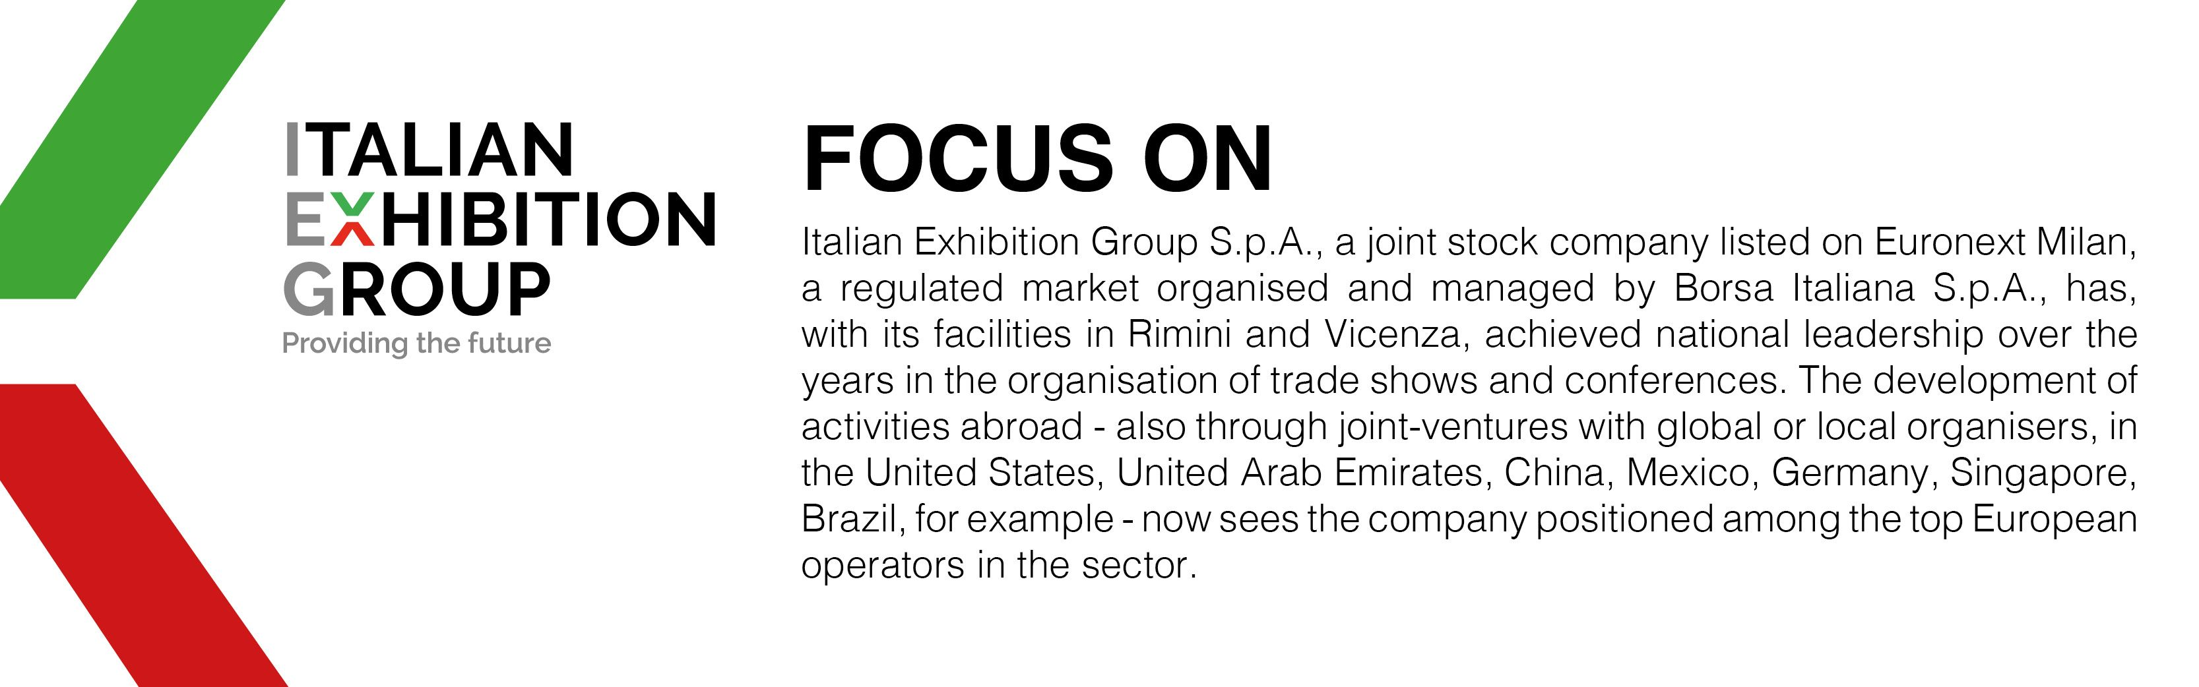

This press release contains forecast elements and estimates that reflect the management’s current opinions (“forward-looking statements”), particularly regarding future management performance, realization of investments, cash flow trends and the evolution of the financial structure. For their very nature, forward-looking statements have a component of risk and uncertainty, as they depend on the occurrence of future events. The effective results may differ (even significantly) from those announced, due to numerous factors, including, only by way of example: food service market and tourist flow trends in Italy, gold and jewellery market trends, green economy market trends; the evolution of raw material prices; general macroeconomic conditions; geopolitical factors and evolutions in the legislative framework. Moreover, the information contained in this release does not claim to be complete, and has not been verified by independent third parties. Forecasts, estimates and objectives contained herein are based on the information available to the Company as at the date of this release.

