

final press release
(English translation)

ECOMONDO 2024: THE BIG NUMBERS OF THE LARGEST EDITION EVER.
+5% TOTAL ATTENDANCE, 1,620 BRANDS, 166,000 M² OF EXHIBITION SPACE

- All indicators up for the 27th edition of Italian Exhibition Group's international green technologies event, which closed today at Rimini Expo Centre
- Sustained international attendance at + 4% compared to 2023: Germany, Spain, Romania, France, Croatia, Greece, Serbia, Egypt, Turkey and Tunisia the most represented foreign countries
- Minister Pichetto Fratin: «At Ecomondo, Italy is an ecological transition winner »

https://en.ecomondo.com

Rimini, 8th November 2024 – All the surveys and forecasts say it: sustainability is at the core of urgency and of every future strategy, for society and businesses worldwide. At Ecomondo 2024, the international event on the green and circular economy, organised by Italian Exhibition Group and which ended today at Rimini Expo Centre, this affirmation was translated into a record-breaking edition.
+5% total attendance compared to the previous edition (and +4% foreign attendance), 1,620 exhibiting brands occupying 166,000 square metres inside the Expo Centre, which was extended by two new halls in response to companies’ growing demand (+10% of exhibitors compared to 2023).
A meeting place for corporate technological innovation, the world of research, industry professionals and international delegations that attended the more than 200 conferences and workshops scheduled, also accessible online thanks to the GreentechInsights b2b platform. While the number of accredited journalists from all over the world reached 650 putting the trade show and Rimini in the international limelight.

ECOMONDO, INTERNATIONAL SUSTAINABILITY HUB
The figures confirm Ecomondo's role as a major international hub for the green and circular economy, thanks to synergy with the Italian Trade Agency (ITA) and the Ministry of Foreign Affairs and International Cooperation (MAECI), in collaboration with IEG's global network of regional advisors and the Emilia-Romagna Region. The number of foreign operators continues to grow, mainly from the Euro-Mediterranean area and particularly from Germany Spain, Romania, France, Croatia, Greece, Serbia, Egypt Turkey and Tunisia. International operators from 121 countries, 72 sector associations and institutions at global level, 650 buyers from 65 countries, especially from North Africa, Europe, North America and Latin America, with a significant increase in buyers from Asia. A system of relations and encounters that led to 3,500 business matching sessions during the four days of the show.
The results collected at the end of the event confirm the value of the network of relations that Ecomondo has been nurturing for years, acting as a true “community catalyst” for the green economy at an international level.

MINISTER PICHETTO FRATIN: AT ECOMONDO, ITALY IS AN ECOLOGICAL TRANSITION WINNER
An important presence of institutional representatives underlined the importance of Ecomondo as a place in which to discuss the major issues on the agenda for our country, also in relation to international scenarios.
The Minister for the Environment and Energy Security, Gilberto Pichetto Fratin, who opened the event, recalled how Ecomondo is “a privileged observatory on the national economy. Here Italy is the winner of ecological transition, which aims at decarbonisation, efficiency, the rational use of natural resources and innovation.”

INNOVATION, KEY FOR SUSTAINABILITY
This was the leitmotif that strongly featured at Ecomondo 2024, interpreted in the phenomenon of start-ups, but also by exhibiting brands: in the last 5 years 78.4% of companies have invested in innovation for sustainability (Ecomondo-Unioncamere survey conducted on a sample of companies in the event’s ecosystem).
Innovation was also rewarded at Ecomondo, where the Lorenzo Cagnoni Award for green innovation was given to start-ups that presented cutting-edge solutions and products. Eco-innovation by companies and public administrations was also rewarded with the Sustainable Development Award, promoted by the Foundation for Sustainable Development and Ecomondo.

THE STATE OF THE INTERNATIONAL GREEN TRANSITION
More than 200 appointments spread over the four days of the show offered a complete overview of the latest trends and challenges in the field of sustainability on an international scale: from the Circular Economy to the Bio-Economy, the Water & Blue Economy, climate change monitoring and sustainable finance. These were accompanied by a packed programme of events coordinated by Ecomondo's Technical-Scientific Committee, chaired by Prof. Fabio Fava from Bologna University.
The States General of the Green Economy, whose 13th edition also opened Ecomondo this year, contextualised these topics within a framework of national scenario data: CO₂ emissions reduced by more than 6%, Italy the leading country in the circular economy (3.6 euros of GDP for every kg of resource consumed), more than 44% of electricity production from renewable sources on total generation and national organic production on the increase. Open challenges, such as the progressive increase in soil consumption and the sustainable mobility goal, were also outlined.

A WINDOW ON GREEN PROFESSIONS, MINISTER VALDITARA’S PARTICIPATION
Enormous attention was paid to the issues of training and professional qualification to steer young people towards present and future green professions. On the morning of the last day of Ecomondo, the Minister of Education and Merit, Giuseppe Valditara, spoke about this very topic to outline the training strategies of the future. There is already a significant demand for upskilling and reskilling to cope with the difficulty of finding green professionals in line with companies' investments and projects. University students and professionals attended Ecomondo and participated in the training and orientation initiatives, together with 2,800 high school students.
A successful edition with contributions from historical and important partnerships: supply chain consortia and business associations, starting with CONAI, Utilitalia and Assoambiente, Confindustria, as well as national institutions, such as MASE, MIMIT, ITA, and international entities, from the European Commission, to OECD, FAO, the European Environment Agency and ISWA.

ECOMONDO WILL BE BACK AT ITALIAN EXHIBITION GROUP’S EXPO CENTRE IN RIMINI FROM 4TH TO 7TH NOVEMBER 2025.

PRESS CONTACT - ITALIAN EXHIBITION GROUP
head of media & corporate communication: Elisabetta Vitali; press office manager: Marco Forcellini, Pier Francesco Bellini; international press office coordinator: Silvia Giorgi; press office coordinator: Luca Paganin; press office specialists: Nicoletta Evangelisti, Mirko Malgieri; media@iegexpo.it

MEDIA AGENCY
Hill & Knowlton
Francesca De Angelis, +39 342 7460159 - francesca.deangelis@hillandknowlton.com
Valentina Corsi - +39 3270425730 - valentina.corsi@hillandknowlton.com
Alessio Ricciuto - alessio.ricciuto@hillandknowlton.com
Stampa Estera - Oksana Smirnova - smirnova.consultant@hillandknowlton.com

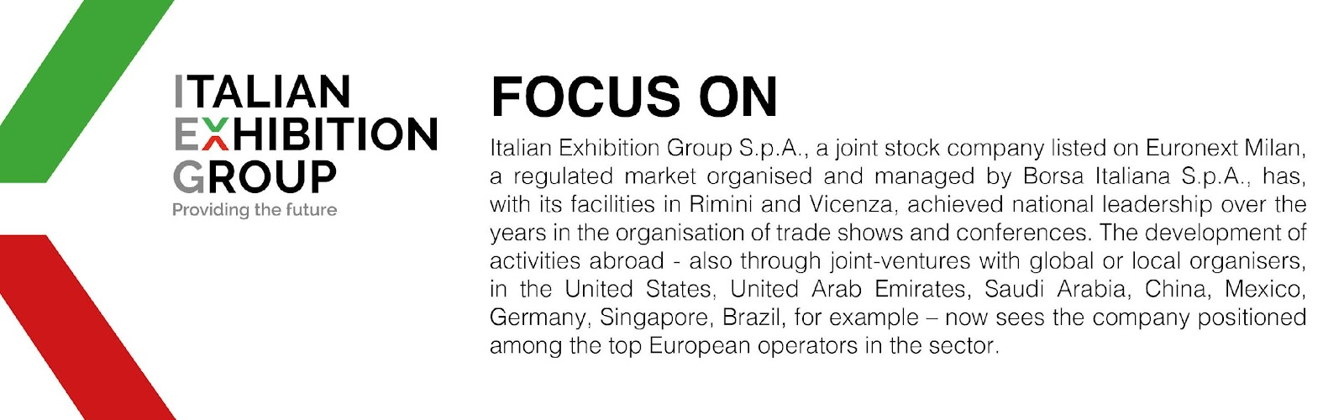

This press release contains forecast elements and estimates that reflect the management’s current opinions (“forward-looking statements”), particularly regarding future management performance, realization of investments, cash flow trends and the evolution of the financial structure. For their very nature, forward-looking statements have a component of risk and uncertainty, as they depend on the occurrence of future events. The effective results may differ (even significantly) from those announced, due to numerous factors, including, only by way of example: food service market and tourist flow trends in Italy, gold and jewellery market trends, green economy market trends; the evolution of raw material prices; general macroeconomic conditions; geopolitical factors and evolutions in the legislative framework. Moreover, the information contained in this release does not claim to be complete, and has not been verified by independent third parties. Forecasts, estimates and objectives contained herein are based on the information available to the Company as at the date of this release.

