HOW TO GET TO AND GET AROUND IBE 2024
Services guide

Rimini, 19-21 November 2024 - Reaching IBE (Rimini Expo Centre, 19-21 November) is easy thanks to the numerous services made available by Italian Exhibition Group for operators and visitors.
Entrance to the expo centre: access from the South entrance (Via Emilia, 155) of Rimini Expo Centre.
Opening hours: The 11th edition of the event will take place from Tuesday 19 to Thursday 21 November 2024. Opening hours are 9:00-18:00.
Ticket office: Admission is free but prior registration is required. For assistance, contact the number +39 0541 744555 or email helpdesk.rn@iegexpo.it.
Services for disabled visitors: Italian Exhibition Group guarantees excellent accessibility to the expo centre for its disabled visitors. Reserved parking, entrances with ramps, interconnected single-storey halls, facilitated toilets and elevators to reach the conference rooms are available. The train station is accessible by lift. Mobility aids such as manual wheelchairs are available free of charge on reservation. To book, simply send this form by email to helpdesk.rn@iegexpo.it. The chair can be collected at the infirmary of the agreed entrance, on presentation of valid ID, and must be returned at the end of the day.

TRANSPORT
Car: From the A14 Bologna-Bari-Taranto motorway, exit at Rimini Nord (6 km from the expo centre).
Train: RiminiFiera station, on the Milan-Bari line, is 50 metres from the south entrance. Regional trains are available. Assistance for passengers with disabilities is available on reservation.
Plane: Rimini - San Marino "Federico Fellini" International Airport is a 15-minute drive away. Other nearby airports include Forlì, Bologna, Milan, Rome, Ancona, Venice, Treviso and Bergamo.
Shuttle Bus Bologna Airport: Runs from Bologna airport to Rimini Expo Centre, with mandatory online reservation at a cost of €25 or board the shuttle directly at Bologna airport and pay €30.
Helicopter: The expo centre has its own helipad. For information: martina.mazzoli@iegexpo.it
Metromare: Connects Rimini and Riccione stations in 23 minutes, with trips approximately every 15 minutes.
Bus: Numbers 5, 10 and 9 serve the expo centre.
Taxi: Call +39 0541/50020.
Parking: 11,000 paid parking spaces in the expo centre.
Mobility Partners
Car Rental: Discounted rates with enjoy, Corrente, AVIS.
Electric Micromobility: Electric bicycles and scooters from Lime and BIT Mobility.

SPECIAL OFFERS
Trenitalia provides the following special offers for Rimini Expo Centre:

- “Special Events” Offer: up to -75% on tickets for Frecciarossa, Frecciargento and Frecciabianca trains with origin/destination Rimini, for purchases via the Trenitalia App, at ticket offices and authorised travel agencies or on the website www.trenitalia.com.
- 30% discount on tickets for Intercity and Intercity Notte trains with origin/destination Rimini, for purchases via the Trenitalia Group Office and authorised Travel Agencies.

PRESS CONTACT - ITALIAN EXHIBITION GROUP
head of media & corporate communication: Elisabetta Vitali; press office manager: Marco Forcellini, Pier Francesco Bellini; international press office coordinator: Silvia Giorgi; press office coordinator: Luca Paganin; press office specialists: Nicoletta Evangelisti, Mirko Malgieri; media@iegexpo.it

MEDIA AGENCY
Twister communications group
Patrizia Vallecchi, +39 335 6334169 - pvallecchi@twistergroup.it
Monica Cipparrone - +39 349 2814894 – mcipparrone@twistergroup.it
Andrea Franceschi - +39 3357485194 - afranceschi@twistergroup.it

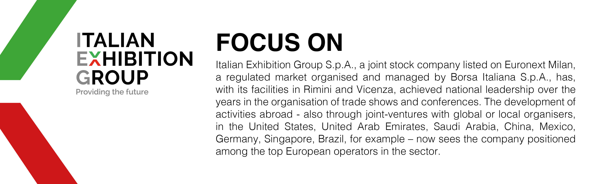
This press release contains forecast elements and estimates that reflect the management’s current opinions (“forward-looking statements”), particularly regarding future management performance, realization of investments, cash flow trends and the evolution of the financial structure. For their very nature, forward-looking statements have a component of risk and uncertainty, as they depend on the occurrence of future events. The effective results may differ (even significantly) from those announced, due to numerous factors, including, only by way of example: food service market and tourist flow trends in Italy, gold and jewellery market trends, green economy market trends; the evolution of raw material prices; general macroeconomic conditions; geopolitical factors and evolutions in the legislative framework. Moreover, the information contained in this release does not claim to be complete, and has not been verified by independent third parties. Forecasts, estimates and objectives contained herein are based on the information available to the Company as at the date of this release.

