press release 5

IBE2024 LAYOUT
Revamped and expanded with new halls and the debut of Intermobility future ways

Rimini, 19-21 November 2024 - For its 11th edition (Rimini Expo Centre, 19-21 November), IBE is presenting a revamped and expanded layout, including not only the industrial vehicle supply chain, but also the new players key to designing a system in line with the objectives of the Next Generation EU for the energy transition.

For the first time, the event will avail of the prestigious South entrance and the exhibition will also occupy the beautiful setting of the dome in the South Hall hosting the main stage, the Innovation District and the new entry, Intermobility Future Ways.

The layout was designed to offer, on the one hand, an intuitive path to access the halls and stands dedicated to the bus industry and supply chain and, on the other, a path to conferences, workshops and institutional events.

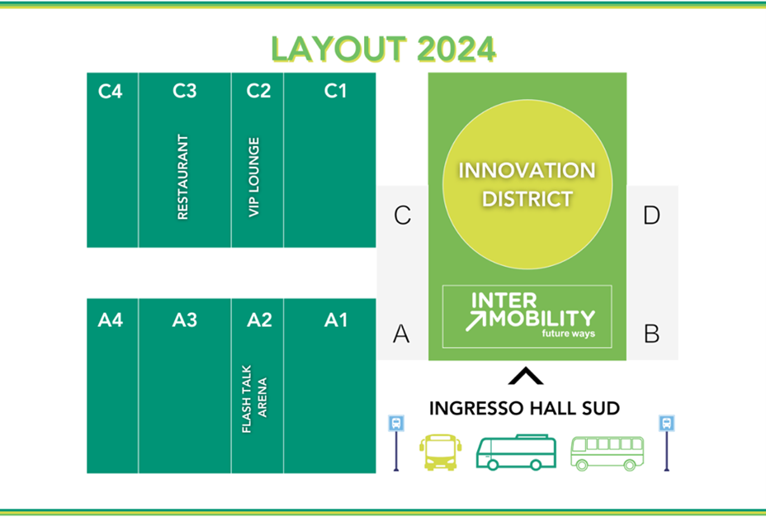

The Innovation District, shared by IBE and Intermobilty future ways and located under the dome in the South Hall, is the hub of innovation, hosting institutions, research centres and companies at the forefront of the ecological transition. This area includes spaces for start-ups, scale-ups and the Green Jobs & Skills project, which promotes the convergence of young talents and companies in the industry and fosters the development of new green skills. The area also hosts plenary conferences organised in collaboration with SUSDEF, the Foundation for Sustainable Development and events such as the “Lorenzo Cagnoni Innovation” Award and the “Lorenzo Cagnoni Innovative Start-up” Award.
The halls in the West area (A1, A3, A4, C1, C3 and C4) are dedicated to the bus sector and its supply chain, where visitors can explore the latest innovations from manufacturers, body shops, components, services, digital technologies and new energy sources.
In addition to the exhibition, Hall A2 also hosts the Flash Talk Arena. Here, each single speaker has 30 minutes and an arena open to the public to address a variety of topics: technology, regulations and industry trends.
Hall C2 is dedicated to the exhibition areas of the technology district companies and the VIP lounge of IBE and IFW.
Refreshment points in the South Hall and the restaurant in Hall C3 are an ideal place to forge networking opportunities between exhibitors, speakers and visitors.

The external areas of the expo centre also play a strategic role, hosting the Test Drives with a route starting from the station square – at the SOUTH entrance and covering roads open to traffic, while the West Square hosts Electric Bus Training, theory-practice courses for electric bus drivers promoted by IBE in collaboration with Addestra, Efficient Driving and Pullman magazine.

PRESS CONTACT - ITALIAN EXHIBITION GROUP
head of media & corporate communication: Elisabetta Vitali; press office manager: Marco Forcellini, Pier Francesco Bellini; international press office coordinator: Silvia Giorgi; press office coordinator: Luca Paganin; press office specialists: Nicoletta Evangelisti, Mirko Malgieri; media@iegexpo.it

MEDIA AGENCY
Twister communications group
Patrizia Vallecchi, +39 335 6334169 - pvallecchi@twistergroup.it
Monica Cipparrone - +39 349 2814894 – mcipparrone@twistergroup.it
Andrea Franceschi - +39 3357485194 - afranceschi@twistergroup.it

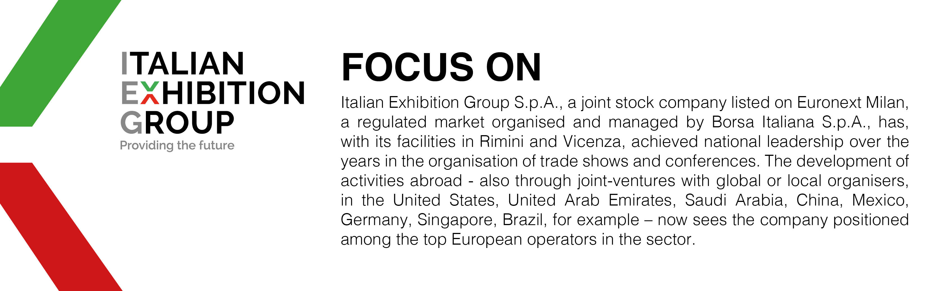

This press release contains forecast elements and estimates that reflect the management’s current opinions (“forward-looking statements”), particularly regarding future management performance, realization of investments, cash flow trends and the evolution of the financial structure. For their very nature, forward-looking statements have a component of risk and uncertainty, as they depend on the occurrence of future events. The effective results may differ (even significantly) from those announced, due to numerous factors, including, only by way of example: food service market and tourist flow trends in Italy, gold and jewellery market trends, green economy market trends; the evolution of raw material prices; general macroeconomic conditions; geopolitical factors and evolutions in the legislative framework. Moreover, the information contained in this release does not claim to be complete, and has not been verified by independent third parties. Forecasts, estimates and objectives contained herein are based on the information available to the Company as at the date of this release.

