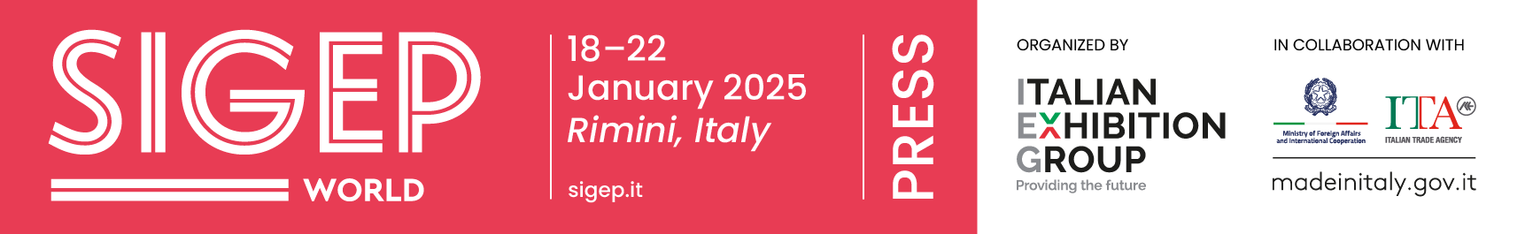

press release
(English translation)

SIGEP LOOKS TO “THE WORLD”, AND THE PREMIER ITALIAN GELATO SHOW IN THE WORLD MAKES ITS PIZZA SPACE EVEN BIGGER

- The 46th edition of the event organized by Italian Exhibition Group will be held in Rimini from 18 to 22 January 2025, with a new pay-off: Sigep World – The World Expo for Foodservice Excellence

- The leading Italian gelato show in the world will also confirm the other 4 supply chains: pastry, chocolate, coffee and bakery. The 2025 edition will feature a large space designated to pizza, an industry worth over 153 billion dollars worldwide

- Thanks to the expansion of Rimini Expo Centre, adding two new pavilions, Sigep will cover over 140 thousand square metres of exhibit area

Rimini, 11 June 2024 – Sigep, the world’s leading Italian gelato fair, is stretching its international reach and broadening its horizons towards the pizza universe, an industry which according to the most recent estimates has a global value of over 153 billion dollars (source Verified Markets Reports). And for the 2025 edition it is giving itself a makeover, starting from the pay-off which will become: "Sigep World - The World Expo for Foodservice Excellence". The reference to World underlines the global scope of the Rimini event recently supported by two new satellite trade shows in markets with great potential such as southern China and the Singapore area.

The event, organized by Italian Exhibition Group, will be held at Rimini Expo Centre from 18 to 22 January 2025. In addition to gelato, the Italian frozen dessert, which remains the core of the exhibition, top foodservice technologies and premium ingredients for the pastry, pizza, bread making, and coffee world will also feature, embracing an increasingly wider community: last year attracted visitors arrived from no less than 160 countries, eager to check out the 1,200 exhibiting brands from 35 countries. And in that same edition, Sigep hosted over 500 buyers from 84 countries, generating more than 5,200 business meetings.

SIGEP 2025 HIGHLIGHTS

The 46th edition will maintain the 5 large supply chains. Gelato will obviously be a shining star. After all, Sigep is the number one Italian gelato fair in the world, with the most complete offering and the participation of all producers, from technologies to ingredients, from semi-finished products to equipment. And alongside gelato, the Italian frozen dessert, there will of course be pastry, bread, chocolate and coffee. But among the new entries is a large space dedicated to pizza: Sigep World will definitely be the most important showcase for the product and its technologies, becoming a true cornerstone. Italian Exhibition Group will also expand the exhibition area, enhancing the exhibition sector with two new pavilions in the east area providing up to 140 thousand extra square metres of exhibit space, to shoulder the growth of this major event.

As always, ample space will be given to the most important talks from all the communities present. In particular, the opening session will focus on the most up-to-date foodservice trends, both national and above all international, confirming Sigep World as the most authoritative voice in the industry thanks to the launch of Sigep Vision, the global observatory on gelato and foodservice trends.

A STRONG INTERNATIONAL PERSPECTIVE

Last January, IEG, in collaboration with ITA-Italian Trade Agency, brought a wave of foreign interest from Europe, the Balkans area, Africa, North America, Central South America, Asia and Southeast Asia to Rimini. And the commitment for the 2025 edition will be doubled with a European road show scheduled for autumn to involve journalists and buyers, thanks also to the collaboration of the group's regional advisors, with particular emphasis on importers, distributors, foodservice and hotel chains. As regards the individual supply chains, the Arenas and international competitions which saw 25 countries participate last January will naturally be confirmed.
Last but not least, particular attention will be given to new trends on a global scale to be presented at Sigep World. Specifically, the latest technologies of automatic coffee machines, with a clear improvement also on the sustainability front, leavened foods and new pastry trends, as well as naturally the gelateria of the future, with the Rimini event being the main driving force behind the diffusion of the Italian ice cream culture throughout the world.

SIGEP ITALIAN EXHIBITION GROUP PRESS CONTACTS
head of media relations & corporate communications: Elisabetta Vitali; press office manager: Marco Forcellini, Pier Francesco Bellini; press office specialist: Mirko Malgieri
international press office coordinator: Silvia Giorgi; media@iegexpo.it

MEDIA AGENCY SIGEP: Mind The Pop
Martina Vacca: martina@mindthepop.it, mob. +39 339 748 4994; Fabrizio Raimondi: fabrizio@mindthepop.it, mob. +39 335 389 848; Benedetto Colli: benedetto@mindthepop.it, mob. 380 371 2272; Stefano Chiossi: stefano@mindthepop.it, mob. + 39 388 739 4358.

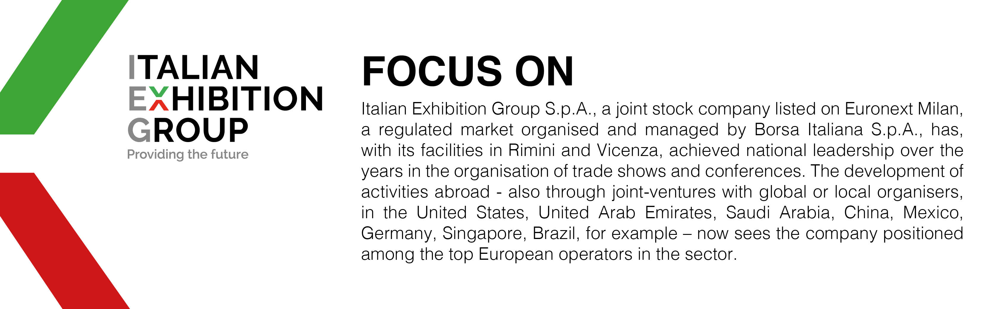

This press release contains forecast elements and estimates that reflect the management´s current opinions (´forward-looking statements´), particularly regarding future management performance, realization of investments, cash flow trends and the evolution of the financial structure. For their very nature, forward-looking statements have a component of risk and uncertainty, as they depend on the occurrence of future events. The effective results may differ (even significantly) from those announced, due to numerous factors, including, only by way of example: food service market and tourist flow trends in Italy, gold and jewellery market trends, green economy market trends; the evolution of raw material prices; general macroeconomic conditions; geopolitical factors and evolutions in the legislative framework. Moreover, the information contained in this release, does not claim to be complete, and has not been verified by independent third parties. Forecasts, estimates and objectives contained herein are based on the information available to the Company as at the date of this release.

